Review topic –

1. Database connectivity (in build environment)
2. Database connectivity (SQL server)
3. Connection string using web configure file
4. Connect database to aspx using C# code (library, object, !ispostback )
5. Perform basic query in C# (insert, update, delete, select)
6. How to use scalar function in a C# (id generation )
7. Data bound control (drop down, etc)
8. Property of data bound control
9. How to break repeated data value using code. (without primary key)
10. How to use session / query sting
11. Data control (grid view)
12. Basic binding
13. Template field concept
14. How to insert control in template field (item template)
15. Grid view event handling (outside control – For each)
16. Grid view footer (show footer)
17. How to display data inside footer. (cells method)
18. Grid view cell counting. (0)

How data

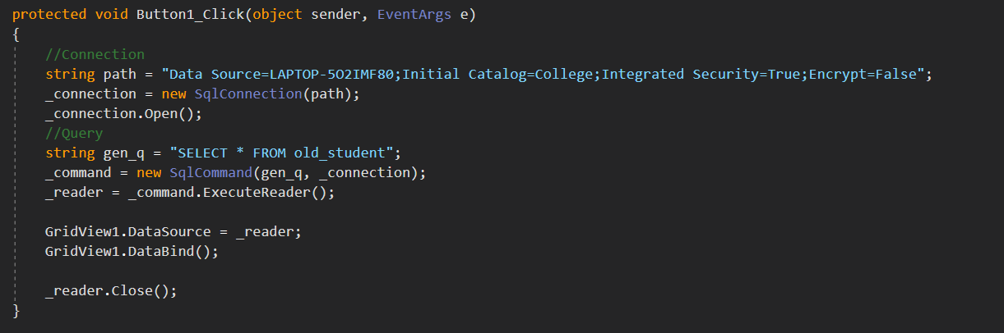

Grid view auto generate column

Roll Name City

1 hello Nagpur

2 world Pune

5 hi delhi

Step 1. Auto generate column is use to template field

<asp:TemplateField HeaderText="Sr No.">

<ItemTemplate>

<%# Container.DataItemIndex+1 %>

</ItemTemplate>

</asp:TemplateField>

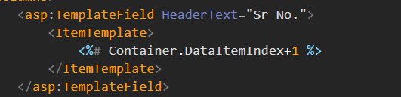

Grid View Error

1. ***Field or property*** does not found/match.

Solution:

* Check your column name
* Data field property
* Blank space in column name

How to bind image in grid view control?

Bind any type of images inside grid view control using image_field property.

There are following property in image field.

1. Header Text
2. DataImageURLField – Pic
3. DataImageURLFormatString = location (Folder Name)

Ex – ~/upload/{0}

How to control image attribute (height, width)?

Using <control style> inside the <image filed>

<asp:ImageField DataImageUrlField="Pic" DataImageUrlFormatString="~/upload/{0}" HeaderText="Student Pic">

<ControlStyle Width="100px" Height="100px" />

</asp:ImageField>



Gird view event handling (inside the control – Naming container)

Step

1. Using template column
2. Create event control inside the template column (Button, Link Button …).
3. Create event using on click statement.

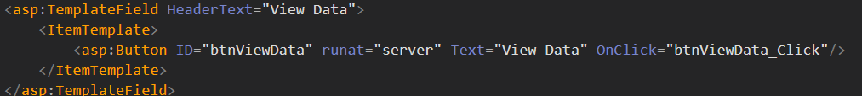

How to create naming container?

Syntax – GridView.Row obj = ((Control)Sender).NameingContainer AS GridView.Row;

Ex- GridView.Row r1 = ((Button)Sender).NameingContainer AS GridView.Row;

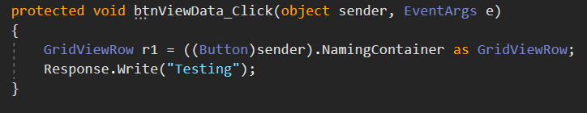

Display cell value inside naming container.

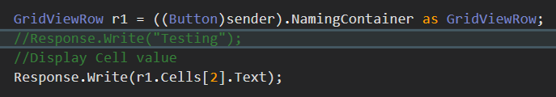

How to find control inside naming Container?

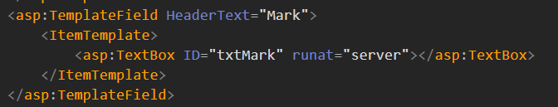

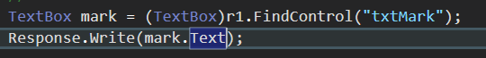

Cells method is not use in development.

Update – UPDATE old_student SET Name = @Name1 WHERE Roll = @Roll1;

Com = new sqlcommand(update, Con);

Com.parameter.addwithvalue(“@Roll1”, r1.cells[1].text);

Dynamic Binding (Control)

1. Dynamic binding process is use to connect database column to specific control (inside grid view)
2. Dynamic binding is used to Eval().
3. Eval() is used (text) property.
4. Syntax – Text = ‘<%# Eval(“ColumnName”) %>’
5. Ex – text = ‘<%# Eval(“Name”) %>’

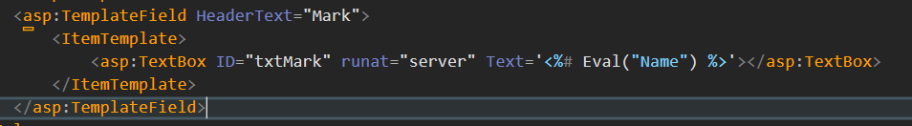

Task 1 –

Generate student admin card using curd operation.

Page Name - Default.aspx

Col

Id

Name

Email

Mobile

College

Branch

Status

Total

Percentage

Grade

Submit – button

Show – button

Logic –

1. Create regDB table.
2. Grade cannot insert by the user.
3. If user can click show button then display record in a grid view

Sr No. Id Name Email Mobile Status Total Grade Action Action Action

Auto tb tb tb tb ddl(a/r) tb tb update delete View

1. If total > 250 – then display A grade inside textbox.

Total > 150 and total < 250 – B Grade in textbox and change the back ground colour = Yellow.

1. Update only status column if user can click update button by default status in blank in a database.
2. Delete login
3. If user can click view button then open report.aspx page and record
4. Display (id, name, email, mobile, status, grade, total)
5. Generate card
6. View button is to be activated only grade = A. Visiable = “true false” enable = true or false
7. Complete task with CSS